Booking website

Definition:
# Source: AI Source: Provided by: [Data Path: Persons Table -> ID Column: 1, Name_En Column: Motasem Essam] -> From: [Chatgpt (GPT‑5 Mini)] on [2/12/2026]
A booking website is a type of website that allows users to reserve or schedule services, appointments, or tickets online.

Simple Definition
# Source: AI Source: Provided by: [Data Path: Persons Table -> ID Column: 1, Name_En Column: Motasem Essam] -> From: [Chatgpt (GPT‑5 Mini)] on [2/12/2026]
Booking website = an online system for reserving something in advance.

What a Booking Website Usually Includes
# Source: AI Source: Provided by: [Data Path: Persons Table -> ID Column: 1, Name_En Column: Motasem Essam] -> From: [Chatgpt (GPT‑5 Mini)] on [2/12/2026]
- Search & availability – find available dates, times, or seats
- Booking / Reservation form – enter details and reserve
- Payment system (optional) – pay online for the reservation
- Confirmation & notifications – email or SMS confirmation
- User accounts (optional) – track bookings, manage reservations

Examples of Booking Websites
# Source: AI Source: Provided by: [Data Path: Persons Table -> ID Column: 1, Name_En Column: Motasem Essam] -> From: [Chatgpt (GPT‑5 Mini)] on [2/12/2026]
- Hotels & Travel: Booking.com, Expedia
- Flights: Skyscanner, Kayak
- Events / Tickets: Ticketmaster, Eventbrite
- Appointments / Services: Doctor appointments, salons, gyms
- Restaurants: OpenTable, Resy

Purpose of a Booking Website
# Source: AI Source: Provided by: [Data Path: Persons Table -> ID Column: 1, Name_En Column: Motasem Essam] -> From: [Chatgpt (GPT‑5 Mini)] on [2/12/2026]
- Let customers book easily online
- Show availability in real-time
- Reduce phone calls or in-person reservations
- Allow secure payments (if required)
- Manage schedules efficiently for the business

Difference from Other Websites
# Source: AI Source: Provided by: [Data Path: Persons Table -> ID Column: 1, Name_En Column: Motasem Essam] -> From: [Chatgpt (GPT‑5 Mini)] on [2/12/2026]
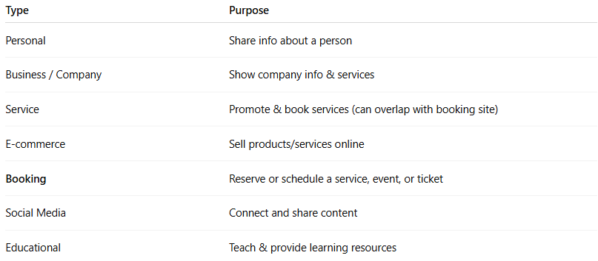
Type | Purpose
Personal | Share info about a person
Business / Company | Show company info & services
Service | Promote & book services (can overlap with booking site)
E-commerce | Sell products/services online
Booking | Reserve or schedule a service, event, or ticket
Social Media | Connect and share content
Educational | Teach & provide learning resources

